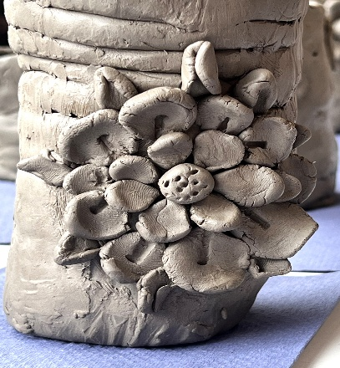
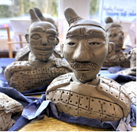

Andrew Hill

Quarry Hill Cottage
Park Lane

Carleton-in-Craven
Skipton
N. Yorks.
BD23 3BH
Tel: 07716 205907
Email:ajhillraku@gmail.com
Web: www.andrewhillceramics.co.uk

Dear Sir/Madam,

Please allow me to introduce myself,
My name is Andrew Hill and during the last 40 years I have become one of the most respected potters in the country, and Raku Potters in Europe, being widely exhibited and collected across the UK, Europe and beyond.
More recently I have been working as a fulltime primary classroom teacher and I have also enjoyed working, as a creative practitioner, in various school environments (including many SEND school sensory based workshops) carrying out residencies and workshops and it with this in mind that I write to you.
E.g. ‘Terracotta Army’ by Y5/6 (as above) …Blessed Trinity Secondary School, Burnley – Hundertwasser inspired ceramics with 36 G & T students across all year groups. I’ve also worked in Special Schools using a sensory approach.
I would like to be considered for a residency or workshop within your school. Ideal for ‘ARTS WEEK!’
As you are probably aware, some of the best things about clay are the tactile and sensory qualities. It can develop fine motor skills and spatial awareness. It is also a creative vehicle for cross curricular subjects, and has the problem-solving aspects of working through processes, whilst encouraging language development.
I can offer a friendly yet professional, unique service covering all creative aspects of art and clay work. Children can also experience “throwing” on the potters’ wheel, (always a favourite). I am DBS checked.
Contact me for costs etc. I can be flexible about all aspects of my work to suit the needs of your school.
Additionally, I offer In-service training sessions (twilights 1.5 – 2 hrs, half or full days) that can be tailored to the needs of the school to improve teachers’ knowledge and skills or provide a fun-based wellbeing session.

Fantastic feedback from some of many successful workshops -

"Thanks again for such a fantastic day. It was wonderful to see the children so focused and engaged and the staff so enthusiastic! We look forward to working with you again soon."

"You're brilliant, amazing with the children!"

"Honestly Andrew, it was amazing and completely exceeded both mine and N's expectations. Hopefully we will see you again in the future."
"Thank you for everything today - it was beyond my expectations! The outcomes are absolutely amazing and the children thoroughly enjoyed the experience."

"Feedback was brilliant...staff asked if you could come every day and they all described how engaged children were and some magical moments, so huge thanks."

Please ring 07716 205907 or email ajhillraku@gmail.com to discuss further or receive more information.
Thank you for your time, and I hope to hear from you soon.

Kind regards

Andrew Hill

